**AI Virtual Painter: Project Report**

**Abstract**  
The AI Virtual Painter is an interactive, vision-based system that enables users to draw virtually on a screen using hand gestures. Utilizing real-time computer vision and machine learning, the system tracks hand movements through a webcam without the need for any physical input device. It serves as a fun, engaging, and educational tool, while also showcasing the practical applications of gesture recognition and artificial intelligence.

**Background and Motivation**  
With the rise of artificial intelligence and human-computer interaction, gesture-based technology has gained significant traction. Touchless interfaces are becoming increasingly relevant in a post-pandemic world that prioritizes hygiene and convenience. The motivation behind this project was to create an innovative platform that provides a hands-free drawing experience—ideal for learning, creativity, and accessibility.

**Problem Statement**  
Traditional drawing applications require physical interaction with touchscreens, styluses, or a mouse. This project addresses the gap in intuitive, hardware-free drawing tools. By using only a webcam and AI-based hand tracking, the AI Virtual Painter eliminates the dependency on external devices, enabling users to interact naturally using hand gestures.

**Project Objectives**

* To develop a real-time virtual painting application using AI
* To explore the potential of computer vision for human-computer interaction
* To create a fun and educational tool accessible to a wide audience
* To minimize the need for physical input hardware

**System Architecture**  
The system architecture is modular and built primarily in Python. It involves the following components:

1. **Video Capture**: Captures live feed from the webcam using OpenCV.
2. **Hand Detection**: Uses MediaPipe to detect and track hand landmarks.
3. **Gesture Recognition**: Determines if the user is drawing, erasing, or changing colors based on finger positions.
4. **Canvas Layer**: Maintains the virtual drawing surface.
5. **Overlay Mechanism**: Combines the canvas and live feed for final output.

**Technologies Used**

* **Python**: Core programming language
* **OpenCV**: Image capture, processing, and display
* **MediaPipe**: Real-time hand tracking and landmark detection
* **NumPy**: Array handling and mathematical operations

**Working & Implementation**  
The AI Virtual Painter functions as follows:

1. The webcam captures a live video feed.
2. MediaPipe detects the hand and identifies key landmarks.
3. The system tracks the index finger to simulate a cursor.
4. If the finger is in drawing mode, it draws lines on a canvas.
5. Different gestures switch between draw, erase, and color modes.
6. The canvas is merged with the video stream and displayed in real-time.

**Applications**

* Digital whiteboards for online teaching
* Art platforms for children and hobbyists
* Interactive installations in museums or events
* Accessible drawing tools for individuals with mobility challenges

**Use Case Scenarios**

* **Students and Teachers**: Enhancing remote learning with virtual whiteboarding.
* **Children**: Encouraging creativity through gesture-based art.
* **Digital Artists**: Exploring gesture-driven design interfaces.
* **Developers**: Prototyping gesture-controlled applications.

**Challenges Faced**

* Ensuring stable hand detection under different lighting conditions
* Reducing lag and optimizing performance for real-time response
* Differentiating between intentional gestures and background noise

**Future Enhancements**

* Adding multi-hand interaction for collaborative drawing
* Integrating shape recognition (e.g., circle, square)
* Introducing voice commands and gesture combinations
* Saving and exporting artwork directly from the application

**Conclusion**  
The AI Virtual Painter is a successful implementation of gesture-based interaction using artificial intelligence. It demonstrates how AI can bridge the gap between physical and digital creativity, offering a novel way of interacting with machines. As gesture recognition continues to evolve, such applications will become more powerful, intuitive, and widely adopted across sectors.

**Result**

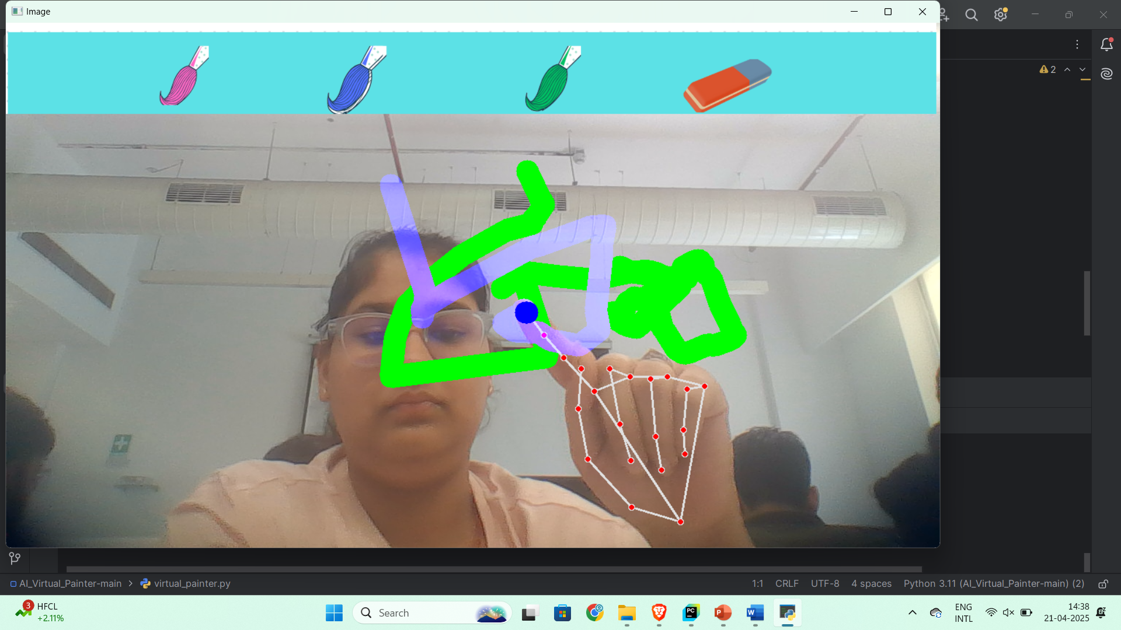

**THANK YOU,**

**GAURIKA AGARWAL  
E23CSEU0369.**